

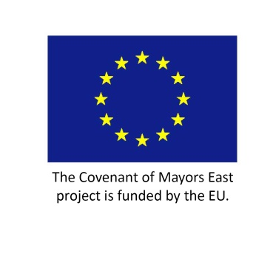

**MEDIA ADVISORY**

**WHO:**

The European Commission (Directorate General European Neighbourhood Policy and Enlargement Negotiations)

**WHAT:**

**HIGH-LEVEL COVENANT OF MAYORS FORUM**

**“Central Asian local and national authorities on the 2020 pathway to a sustainable energy future"**

**WHEN:**

**26 June 2015**

**11:15-11:45 Press briefing**

**WHERE:**

Almaty / Kazakhstan

“Altyn Emel” Conference room, Hotel Kazakhstan, Dostyk Ave 52/2

**ADDITIONAL INFORMATION:**

Momentum is building towards the **UN climate conference in December** this year where governments will agree on a future global cooperation scheme to address the causes and impacts of climate change. Central Asian local authorities can be a blueprint for the negotiators of the Paris climate talks: an increasing number is joining the community of 6300 cities having signed the Covenant of Mayors initiative worldwide and committing voluntarily to increase energy-efficiency and reduce CO2 emissions on their territories.

As we look beyond the Paris agreement and towards the **Expo-2017 Astana** on “Future Energy”, how can city-related initiatives like the Covenant of Mayors support and effectively link to national and international energy and climate policies? How do energy strategies need to be shaped to enhance a **sustainable and prosperous future for Central Asia**?

With **eminent speakers** being expected, the Forum is a great opportunity to meet committed cities from all over Central Asia as well as **representatives of international and national political and financial institutions**. This is the place for media stories from the ground on how climate change is being perceived and how climate and energy issues are being tackled by authorities!

*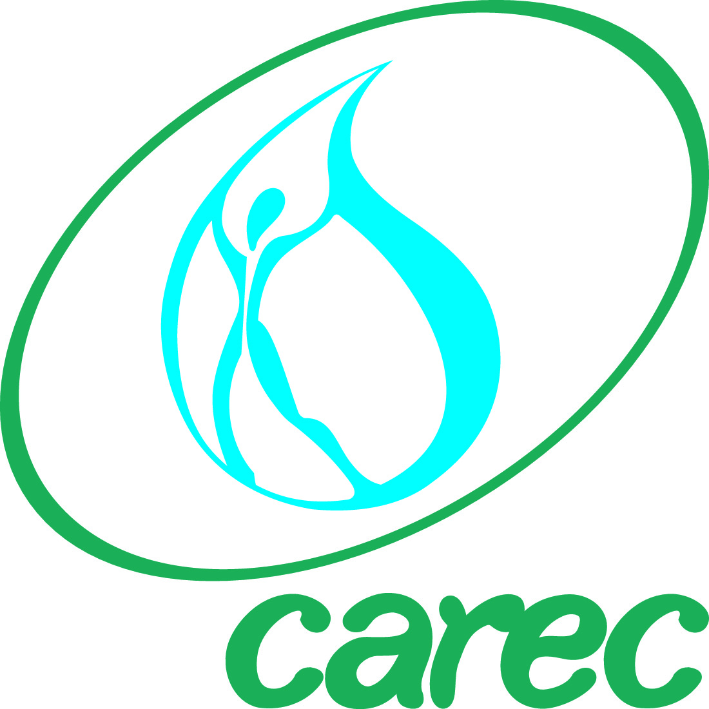In Central Asia, the Covenant of Mayors initiative is coordinated by the Regional Environment Centre for Central Asia (CAREC). Based on a set of principles such as long term commitment, citizens’ involvement, and ambitious and integrated climate action, the Covenant has become a reference for multi-level governance beyond EU borders.*

**PRESS HIGHLIGHTS include:**

* **Welcome Address** with expected Kazakh high-level speakers Akhmetzhan Yessimov (Mayor of Almaty, Kazakhstan) and Mr. Albert Rau (Vice-Minister of Investment and Development), Mrs. Aurelia Bouchez (EU Ambassador in Kazakhstan) as well as other high-level EU Commission representatives - 9.15 am
* **Speeches** expected by Saltanat Rahimbekova (Managing Director of “Astana EXPO-2017”), Heinrich Wyes (Deputy Executive Director CAREC), Batyrkul Bayetov (State Secretary of the Kyrgyz Ministry of Energy and Industry) – 10.00 am
* **Family picture** – 11.00 am
* **Press briefing** – 11.15 am
* **Presentation of upcoming financial and technical assistance** – 11.45 am
* **Face-to-face interviews** with participants (subject to prior arrangement)

**Journalists planning to attend are kindly asked to confirm their participation by sending an email at** [centralasiaforum@eumayors.eu](mailto:centralasiaforum@eumayors.eu)

For any face-to-face interview, you may send an email to [centralasiaforum@eumayors.eu](mailto:centralasiaforum@eumayors.eu)

or call the event coordinator Miriam Eisermann at +33 381 65 36 82.

Interpretation will be provided from/to English and Russian.

For more information about the Covenant of Mayors initiative, visit our Russian [website](http://www.covenantofmayors.eu/index_en.html): [www.soglasheniemerov.eu/index_ru.html](http://www.soglasheniemerov.eu/index_ru.html) .

With my best regards,

Miriam Eisermann



**Miriam Eisermann**

**Communication Manager – Covenant of Mayors East**

Tel.: +33 381 65 36 82

[www.soglasheniemerov.eu](http://www.soglasheniemerov.eu/)